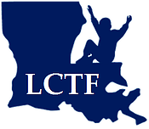
Louisiana Children’s Trust Fund
Board Meeting
November 9, 2017

AGENDA

- Call to Order
- Welcome & Introductions
- Approval of Minutes (May 5, 2017 meeting) and November 9th Agenda
- Financial Report
- Election of Officers
    - Chairman
    - Vice-Chairman
- Committee Assignments
    - Executive Committee
    - Grant Review Committee
    - Legislative Committee
- New Business
    - Technical Support & Evaluation Proposal - LSU Office of Social Services Research & Development (OSSRD)
- LCTF Executive Director’s Report
    - Update on Grantee Applications & Process for Approval
    - Grantee Meeting - December 14, 2017 (tentative)
    - Board Training with FRIENDS - December 14, 2017 (tentative)
- Public Comments
- Adjournment
Next Board Meeting Date: December 14, 2017 (tentative)

